

Refund and ChargeBack- customer

SYSTEM DESIGN DOCUMENT

Version 1.0

Confidentiality Statement

**This document contains information that is proprietary and confidential to Tata Consultancy Services Limited, which shall not be disclosed outside Transport for London, transmitted, or duplicated, used in whole or in part for any purpose other than its intended purpose. Any use or disclosure in whole or in part of this information without express written permission of Tata Consultancy Services is prohibited. Any other company and product names mentioned are used for identification purposes only and may be trademarks of their respective owners.**

**© Copyright <2021>, Tata Consultancy Services (TCS)**

TATA Code of Conduct

**We, in our dealings, are self-regulated by a code of conduct as enshrined in the ‘TATA Code of Conduct’. We request your support in helping us adhere to the code in letter and spirit. We request that any violation or potential violation of the code by any person be promptly brought to the notice of the Local Ethics Counsellor or the Principal Ethics Counsellors or the CEO of TCS. All communication received in this regard will be treated and kept as confidential.**

**Table 1: DOCUMENT REVISION LIST**

|  |  |  |  |
| --- | --- | --- | --- |
| Revision No. | Revision Date | Author | Revision Description |
| v1.0 | 01-Nov-2021 | Pranav Gandhi | This document covers Refund and Chargeback process Initiated by customer. |

CONTENTS

1 Introduction 7

1.1 Purpose 7

1.2 List of Abbreviations 7

1.3 Audience 8

2 Process Description 9

2.1 Refund 10

2.1.1 Pre-Requisite 10

2.1.2 Business Process Map 10

2.1.3 Form Specifications 12

2.1.4 Validations & Business Rules 14

2.1.5 Outcome of the Process 14

2.2 Chargeback 14

2.2.1 Pre-Requisite 15

2.2.2 Business Process Map 15

2.2.3 Form Specifications 16

2.2.4 Notifications 16

2.2.5 Validations & Business Rules 16

2.2.6 Outcome of the Process 17

**Table of Figures**

Figure 1: Business Process Map: Refund 10

Figure 2: Process Map of Chargeback 15

Table of Tables

Table 1: DOCUMENT REVISION LIST 3

Table 2: List of Abbreviations 7

Table 3: Process and Sub-process List 9

Table 4: Form Specifications: Initiate Refund Screen 12

Table 5- Alert and Notifications – Initiate Refund Screen 13

Table 6- Business Rules and Validations- Initiate Refund Screen 14

Table 7: Validations & Business Rules: Initiate Refund 14

Table 8: Business Rules and Validation 16

# Introduction

## Purpose

The objective of this document is to outline design for Refund and Chargeback process that will be initiated from Customer Portal. This document specifies Pre-Requisites, Business Process Maps associated with process, Form Specifications, Actions and Stakeholder details, Business Rules and Validations, Alerts and Notification, and Integration.

* Refund
* Chargebacks

## List of Abbreviations

**Table 2: List of Abbreviations**

|  |  |
| --- | --- |
| Abbreviation | Expanded Form |
| TfL | Transport for London |
| TCS | Tata Consultancy Services Ltd. |
| TPH | Taxi and Private Hire |
| PHV | Private Hire Vehicle |

## Audience

This document is intended to provide an understanding on business functions to different teams:

* TfL Project Management
* TfL SME
* TCS Project team for Designing and developing Payment Process

# Process Description

The Refund process is to initiate refund of payment made against type of service by customer for a suitable reason as selected by the user. The request created by the user shall be sent to TFL for verification and approval. If approved the user shall be refunded the amount via same payment method which was used during the original payment provided it is still valid otherwise cheque will be issues to the customer.

The Chargeback process is initiated by the customer through the bank. Bank will refund the amount claimed by customer. After that, chargeback request will be received by TFL. Then customer will be notified by TfL about the processing of chargeback. The customer will be able to view the status of the chargeback request. TFL shall process the chargeback request and if approved the charges shall be credited to the requested bank. In case of chargeback is not approved by TfL, then the amount will be raised as a debt to customer and payment will be requested from customer. If customer makes payment, then debt will be removed, and customer can continue to use licence issues by TfL. In this chargeback request will be closed. In case of customer does not pay the debt amount then, Licence suspension and revocation process will be triggered.

**Table 3: Process and Sub-process List**

|  |  |  |  |  |
| --- | --- | --- | --- | --- |
| **Process** | | **Application** | | **Description** |
| 1 | Refund | Refund Initiation screen | Online | This screen will come for customer for initiating the refund. Once the request is submitted the TFL shall process the request. |

## Refund

This Process will be available at Customer portal. The user will be able to raise a refund request using the process. Once the request is submitted, TFL shall validate and process the request and take a decision of either approval or rejection. If the request is approved the customer will get the refund in the same account from which the payment was made provided if it’s still is valid or will be issued a cheque. The Customer will be notified over PMOC to confirming the submission of the request and post processing of the request.

### Pre-Requisite

* Customer should hold an active and valid customer account.
* Customer should have paid fee for which the refund is being claimed for.
* Refund should not be initiated against same request

### Business Process Map

**Figure 1: Business Process Map: Refund**

**Process Flow Description: Raise Request (Online)**

* Customer can initiate refund from 3 channels
  + Online portal
  + Email/ Telephone/ In person
  + Post

Flow for Refunds through Online Portal

1. Customer will login to the Online Portal
2. Customer shall search the payment for which Refund is supposed to be requested
3. Customer selects the particular payment request
4. Customer will fill the details and select the reason and submit the request
5. Customer will receive the request reference number for refund and a notification on PMOC
6. After submission Refund request will go to TPH Operations Team
7. User from TPH Operations will check the details if details are not sufficient to process the chargeback then user will request further details/ clarification from customer via PMOC
8. If customer fails to provide requested additional information, then Refund process will end and no amount will be refunded, and customer will be notified with Refund rejection reason
9. If customer responds to additional information and details are complete the refund will be calculated and refund will be issues via original payment method
10. If original payment method is valid then Refund Receipt will be issued and sent to customer via PMOC
11. If original payment method is not valid, then request will be sent to print supplier to issue the Cheque and send to customer
12. At any stage id details are found incomplete/ invalid the Refund request will be rejected and notification for the same will be sent vis PMOC

Flow for Refunds through Email/ Telephone/ In person

1. Customer can request refund via mentioning the details in Email or can call to CSR or will come in person
2. In call cases CSR will create the refund request and process will be continued as mentioned above after point 6

Flow for Refunds through Post

1. Customer can request refund via mentioning the details in letter and send the same via Post
2. In this case, letter will be scanned by scan supplier and send for ICR/ OCR extraction
3. After ICR/ OCR, Refund request will be initiated by CSR and then process will be continued as mentioned above after point 6.

### Form Specifications

This section describes form specifications for raising a refund request. Form specification contains following attributes:

**Field Name** – Indicates name of the field

**Field Type** – Indicates Data Type of field e.g., Textbox, Label, Datebox, Dropdown etc.

**Field Length** – Indicates Length of the field

**Description** – Details like brief description, condition, information etc.

**M/ O/ C/ A** – Indicates field is Mandatory, Optional, Conditional or Auto-populated

#### Form: Refund Initiation Screen

This form will be available at customer online portal. This form will be available to customer after selection of the Payment record from the form “2.1.3.2 Form: View Payment Account” refer to document “TCS Lot 1 TfL – System Design Document for Payment-Customer.docx” and action as “Initiate Refund” against the record.

**Table 4: Form Specifications: Initiate Refund Screen**

|  |  |  |  |  |  |  |
| --- | --- | --- | --- | --- | --- | --- |
| **Sub-Section** | **Field Name** | **Field Type** | **Field Length** | **Description** | **M/O/C/A** | **Remarks** |
| ***Transaction Details*** | Transaction Reference Number | Label |  | Denotes Txn. Ref. Number | A |  |
| Transaction Date & Time | Label |  |  | A |  |
| Payment Mode | Label |  |  | A |  |
| Payment Amount | Label |  |  | A |  |
| Application/ Licence Type | Label |  | Denotes types: Driver Licence/Vehicle Licence/etc. | A |  |
| Application/ Licence Reference | Label |  |  | A |  |
| Application/ Licence Status | Label |  |  | A |  |
| ***Refund***  ***Details*** | Reason for Refund | Dropdown |  | User selects reasons for refund.  - Application Withdrawn  - Application Refused  - Application Rejected  - Retirement  - Deceased Driver  - Special refund | M |  |
| Other Reason | TextArea | 500 | User provides any other reasons for refund | O |  |
| Remarks, if any | TextArea | 500 | User provides any additional remarks that may assist CSR in approving the request | O |  |
| Supporting Documents | Attachment |  | User provides any applicable supporting documents | O |  |

##### **Actions & Stakeholders**

**Stakeholder**: Customer

**Actions**:

**Submit:** - On click of submit button, customer’s request will be submitted in the system for TFL to process. Refund request number will be created and shown to customer.

**Close: -** The unsaved changes shall be lost, and the user will be navigated to the previous screen.

##### **Alert and Notifications**

**Notification**

**Table 5- Alert and Notifications – Initiate Refund Screen**

|  |  |  |  |
| --- | --- | --- | --- |
| **Channel** | **Notification** | **Trigger Event** | **Notified To** |
| PMOC | Your request has been successfully been submitted. | If request is submitted successfully. | Customer |
| PMOC | Notification on approval of Refund request | Approval of refund request | Customer |
| PMOC | Notification on Rejection of Refund request | Rejection of refund request | Customer |
| PMOC | Notification for requesting additional information | Further details required | Customer |

##### **Business Rules and Validations**

**Table 6- Business Rules and Validations- Initiate Refund Screen**

|  |  |  |
| --- | --- | --- |
| **Sr. No.** | **Business Rules** | **Remarks** |
|  | The user shall only be able to initiate a refund provided the Refund request is not in progress/completed |  |
|  | The Service System shall provide the capability to prevent new cheques from being issued to a Customer if a previous Cheque was issued to a Customer for that Refund, or if the previous issued cheque was not banked within six (6) months of issue, subject to Business Rules. |  |

### Validations & Business Rules

**Table 7: Validations & Business Rules: Initiate Refund**

|  |  |  |
| --- | --- | --- |
| Sr. No. | Business Rules | Remarks |
| 1 | All the mandatory validations mentioned on form level  should be performed and highlighted. In case of all  validation is proper then Reference number will be  generated and displayed on screen. |  |

### Outcome of the Process

* Request number will be generated on submission of the request.
* Refund receipt will be generated on successful payment of refund amount.

**Open Points**

* Format for Refund Receipt on successful process of Refund
* Format for each notification mentioned in Section 2.3.1.1

## Chargeback

This Process will be available at Customer portal. The user will be able to raise a refund request using the process. Once the request is submitted, TFL shall validate and process the request and take a decision of either approval or rejection. If the request is approved the customer will get the refund in the same account from which the payment was made provided if it’s still is valid or will be issued a cheque. The Customer will be notified over PMOC to confirming the submission of the request and post processing of the request.

### Pre-Requisite

* Customer should hold an active and valid customer account.
* Customer should have paid fee for which the refund is being claimed for.
* Refund should not be initiated against same request

### Business Process Map

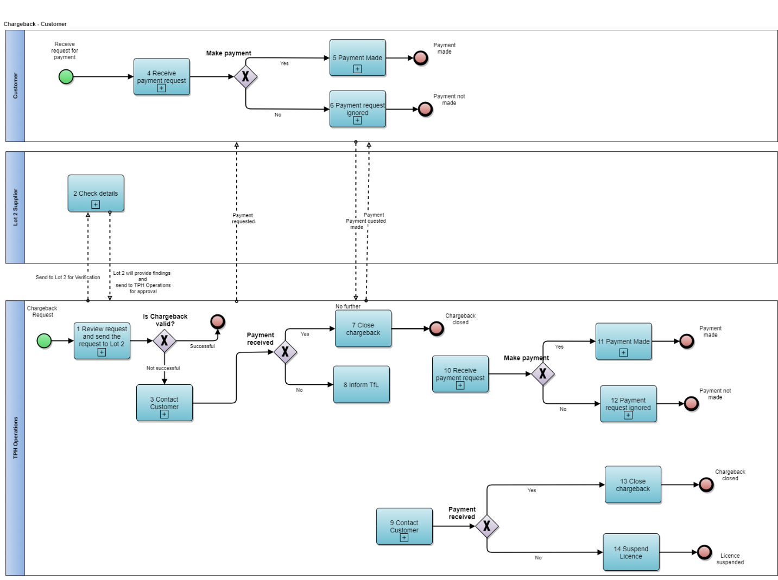

**Figure 2: Process Map of Chargeback**

**Process Flow Description: Raise Request (Online)**

* Customer will request the Chargeback from the bank and bank will credit the amount to customer of Chargeback request
* Bank will then send request of Chargeback to TfL then Chargeback will be processes as the following
  1. TPH Operations Team will receive the request for Chargeback. After initial review the request will be sent to Lot 2 supplier for verification purpose.
  2. Lot 2 team will check the customer details like payment details, licence details etc.
  3. Then, the request will be forwarded to TPH operations for further actions.
  4. If Chargeback is valid then process will be ended. If Chargeback is not valid then debt will be created for customer then, TPH user will contact customer and request for payment as the original amount paid was refunded by bank to customer. Customer will receive notification via PMOC to make payment.
  5. If customer, agrees to pay then payment will be recorded against customer and debt will be removed.
  6. If customer ignores payment request then, (14) Licence suspension and revocation process will be triggered
  7. If customer agrees to pay then, Chargeback will be closed, and customer will be notified for the same.

### Form Specifications

There is no specific form for Chargeback for customer as customer will use Make Payment option to make the payment from online portal. This form is mentioned in “TCS Lot 1 TfL – System Design Document for Payment-Customer.docx” document in Section 2.1.3.1

### Notifications

|  |  |  |  |
| --- | --- | --- | --- |
| **Channel** | **Notification** | **Trigger Event** | **Notified To** |
| PMOC | Notification for Making Payment towards invalid Chargeback | TPH will take decision on recommendation given by Lot 2 | Customer |
| PMOC | Notification on receipt of Chargeback payment | Receipt of Payment against Payment requested for Chargeback | Customer |
| PMOC | Notifications on non-receipt of payment for chargeback from customer | At a certain frequency – If customer does not pay | Customer |
| PMOC | Notification on Initiating Surrender of Licence request in case of Non-receipt of Payment | Initiating Surrender of Licence request in case of Non-receipt of Payment | Customer |

### Validations & Business Rules

**Table 8: Business Rules and Validation**

|  |  |  |
| --- | --- | --- |
| Sr. No. | Business Rules | Remarks |
| 1 |  |  |

### Outcome of the Process

* Payment receipt will be generated on successful payment of Chargeback.

**Open Points**

* Format for each notification mentioned in Section 2.2.4
* Frequency of sending Notifications to customer on non-receipt of payment against a Chargeback.